**ycFeedbackA2**

**Home Page**

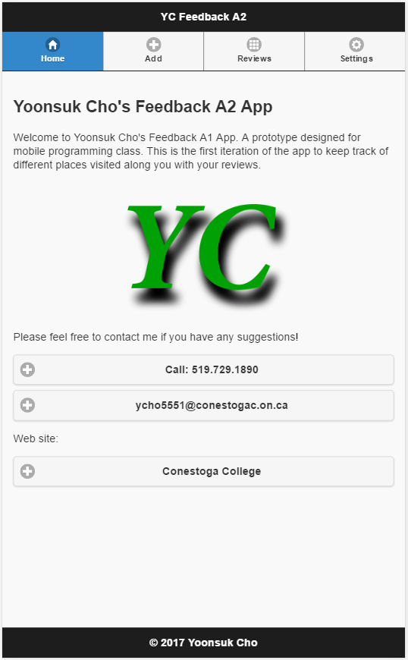

**Add a Feedback page with checkbox unchecked**

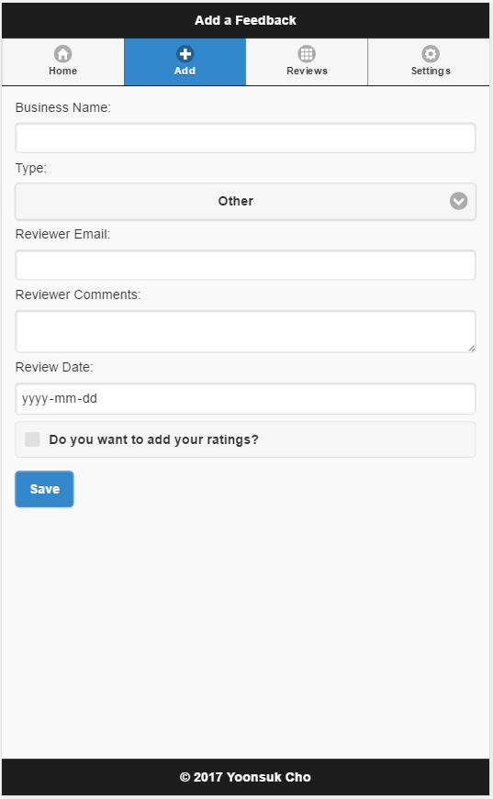

**Add a Feedback page with checkbox checked and with validation checked**

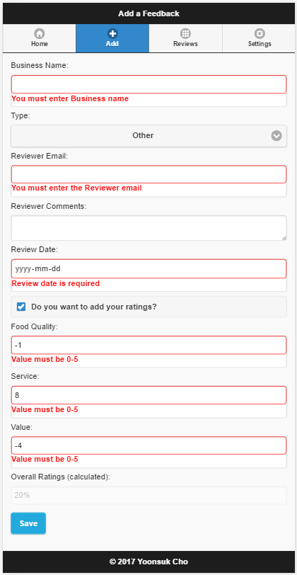

**Modify Feedback page with validation checked**

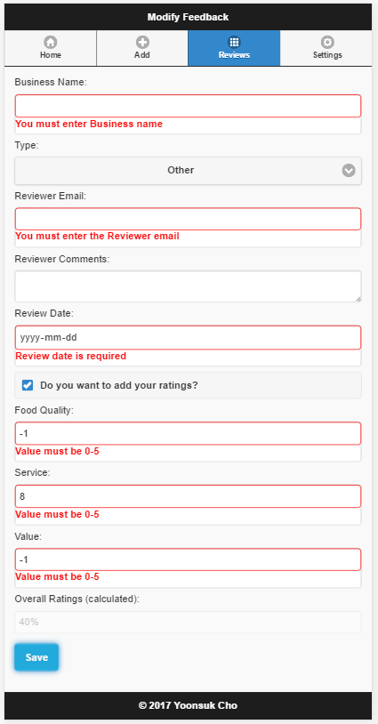

**Settings page with alert (as shown above)**

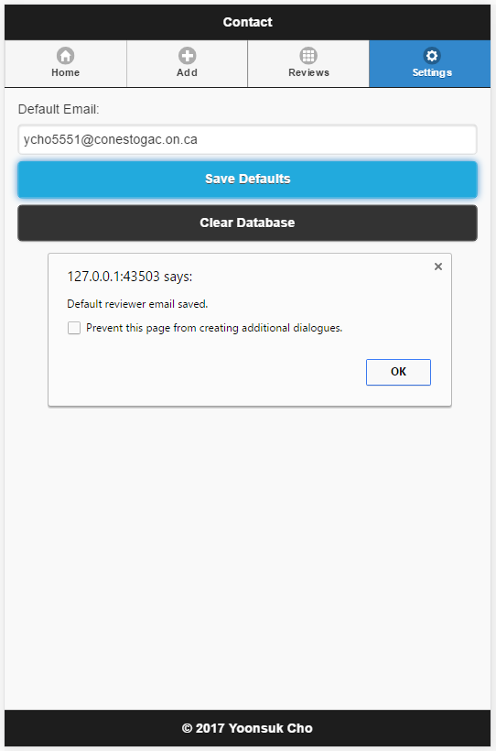

**Developers tool containing Local Storage information (just like the screenshot above)**

